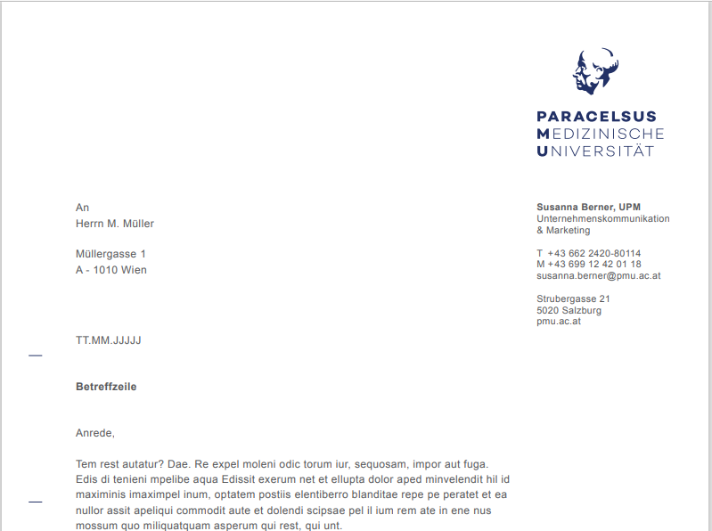

PMU Research and innovation fund (PMu-RIF)

Letter of Confirmation

|  |  |
| --- | --- |
| PMU-RIF funding category: |  |
| Confirmed by: |  |
| Project title: |  |
| Name of applicant: |  |

Herewith I, , fully confirm my support for the above mentioned proposal in case of selection to be performed at my institute/clinic/research program.

Sincerely,

|  |
| --- |
|  |
|  |
|  |